# Lesson 4 project 2025/5/16

.ipynb -> for study and research

.py -> for project

.py will not show the ‘flask core’ at the top right core of VS code. Instead, select below icon in the lower right corner for the virtual environment.



If lower right corner can’t select ‘flask’ then go to top middle text box and enter

‘Python: select’ to select ‘flask’ environment.

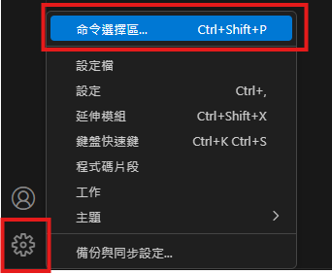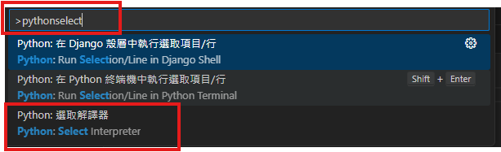

Flask is a web server.

Install Flask package:

Refer to Flask website.

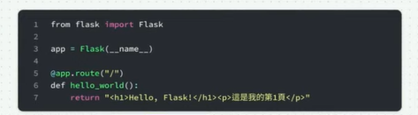

Flask is a class.

__name__ is the bult-in name of the web page. Actually, it is main.

app is an instance of Flask.

route() is a Decorator so ‘@’ is needed before ‘app’. Decorator就是註冊

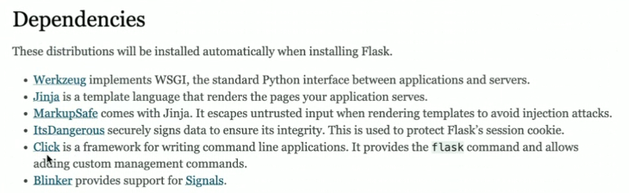

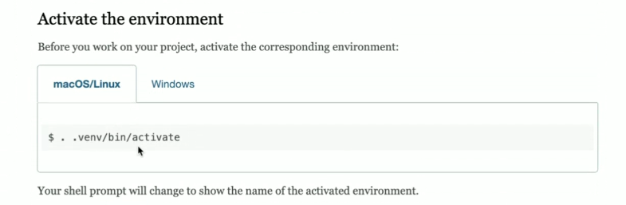

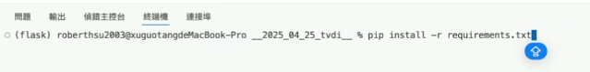

Add packages you would like to install in a ‘requirements.txt’ file, which includes

Note:

1. Add new terminal in the root directory.

2. use ‘pip install -r requirements.txt’ to install all packages in the file.

Try flask minimal application:

Copy below codes in the index.py file.

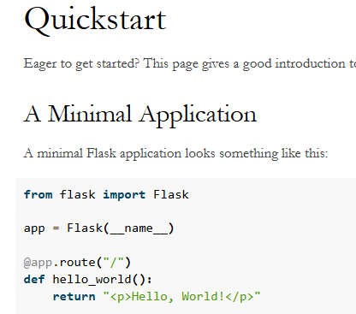

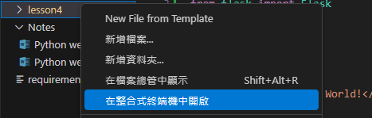

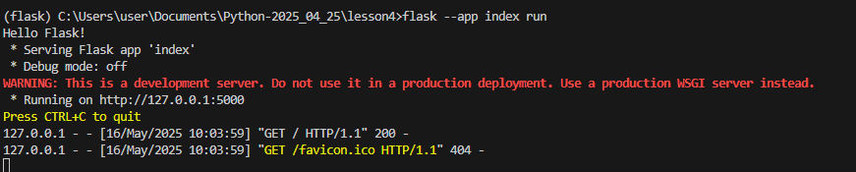

Enter ‘http://127.0.0.1:5000’ in browser to see the results.

Once there is modification in the index file. For example: Change <p></p> to <h1></h1>, you need to restart the server.

If you would not like to restart the server after modification, you need to enter the debug mode. Use below commands –debug to enter the debug mode as below.

>flask –app index run --debug

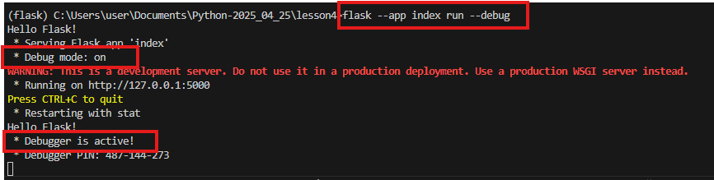

In debug mode, you just need to reload this page then the web contents in the browser will be updated.

* Rendering templates

Install Extension: Install Jinja, author: wholroyd

Figma software to design the web page and generate the html & css files.

Shift+0: Zoom to 100%

Shift+1: Zoom to fit.

Shift+2: Zoom to select

Ctrl+-: Zoom out

Ctrl++: Zoom in

Ctrl+0: Zoom to 100%

* Add extension: Google code assist